Dear reader,
I’m sure you already know that Russia is one of the main players in the global energy system.
However, Russia is facing a difficult situation. Despite its status, the price of Russian oil closely follows that of Brent crude.
That is why, in Russia, Urals crude futures were launched for open trading in order to move away from dependence on Brent pricing. However, to this day, prices are still largely determined based on the Brent benchmark.
Among developing countries, Russia’s oil market—as one of the largest oil producers—deserves special attention.
As a consequence, Russia does not have full sovereignty over the pricing of its commodities, since these prices are determined in international markets.
Regarding this issue, there are several studies and papers that examine this relationship in greater depth.
(Bouoiyour et al., 2015) analyze the nexus between oil prices and Russia’s real exchange rate, conditioning on potential control variables across well-specified horizons and on a frequency-by-frequency basis.
(Vasiljeva et al., 2019) examine the possibilities of establishing conditions to ensure crude oil market pricing through the development of exchange-based trading.

Both studies arrive at a similar conclusion: state oil purchases. Through this approach, the Russian government could ensure that the domestic market has sufficient liquidity and that traders benefit from more stable pricing.

However, the most concerning points are those highlighted by (Polbin, 2017) and (Chernyaev and Kreydenko, 2018).
The former estimates the impact of terms-of-trade shocks on Russian output, gross investment, and consumption using a mathematical VECM model with exogenous variables. The results show that a permanent increase in oil prices leads to a short-term economic boom, followed by a negative contribution to long-term economic growth.
On the other hand, these studies argue that the Russian oil and gas industry (OGI) is currently operating in a state of exhausted industrial potential. It faces significant challenges that hinder its development and threaten Russia’s energy security.
In this sense, it can be said that Russia is trapped between an international market that dictates its prices, an economic structure that suffers when oil prices rise excessively due to its dependence, and a physical infrastructure that is becoming increasingly old and obsolete.
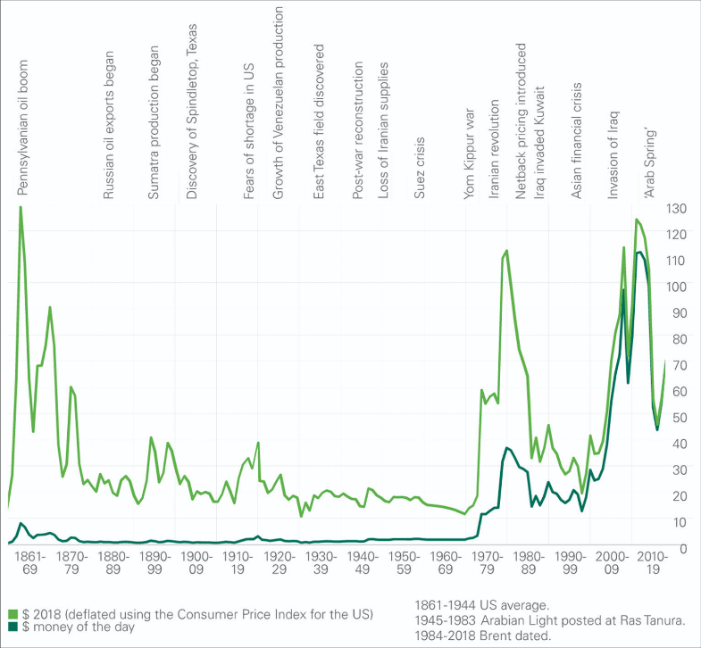
Before talking more deeply about Russia we should understand (In the above image), How control over oil prices has shifted: from large international corporations to oil-producing countries (OPEC) and, ultimately, to financial markets.

Stage 1: The Rise of OPEC (1970s)
Until the late 1960s, the global oil market was dominated by a small group of major international oil companies known as the “Seven Sisters” (such as Exxon, Shell, and BP).
These corporations controlled not only oil extraction but also pricing, operating under concession systems that heavily favored them.
The 1970s marked a turning point: a structural shift in the balance of power in the global energy market, driven by producing countries organized within the OPEC.
OPEC as a political weapon
The creation of OPEC provided, at times, a political weapon against Western countries, as demonstrated on several occasions:
During the 1973 Oil Crisis, in response to Western support for Israel during the Yom Kippur War, Arab OPEC members imposed an oil embargo. Prices skyrocketed, and supply shortages severely affected Western economies.
Between the collapse of Bretton Woods (1971) and the 1973 oil shock, a new monetary order emerged.
Oil-exporting countries(especially Saudi Arabia) agreed to price oil exclusively in U.S. dollars, in exchange the US, security guarantees in the Gulf, strategic protection of regimes and access to global financial markets
However, a second shock followed with the 1979 Oil Crisis, triggered by the Iranian Revolution, which once again disrupted oil production.
From corporate control to state control
However, the most significant transformation was the reassertion of sovereignty over natural resources by producing states. Countries began nationalizing their oil industries or fundamentally renegotiating the terms under which foreign companies operated.
This meant moving from a concession systems, where foreign firms held extensive rights over exploration, production, and profits to a long-term contracts and participation agreements, where the state retained ownership of the resource and dictated the terms.
The production nationalized but FOB remain private
With production increasingly under national control and transport and logistics often still in private hands, the FOB (Free on Board) pricing system became standard.
So, under FOB:
Oil prices are set at the point of export (the loading port).
Buyers assume responsibility for transportation, insurance, and related risks from that point onward.
Basically, that means, producing countries controlled the value of crude at the source and international oil companies retained influence through shipping (tanker fleets) and global distribution networks.
So while oil majors lost direct control over reserves, they remained important actors in downstream and logistical segments.
The emergence of National Oil Companies
The rise of National Oil Companies (NOCs) like Saudi Aramco and PDVSA wasn’t just ideological (“resource nationalism”)—it was economically rational once a few conditions changed in the 1970s:
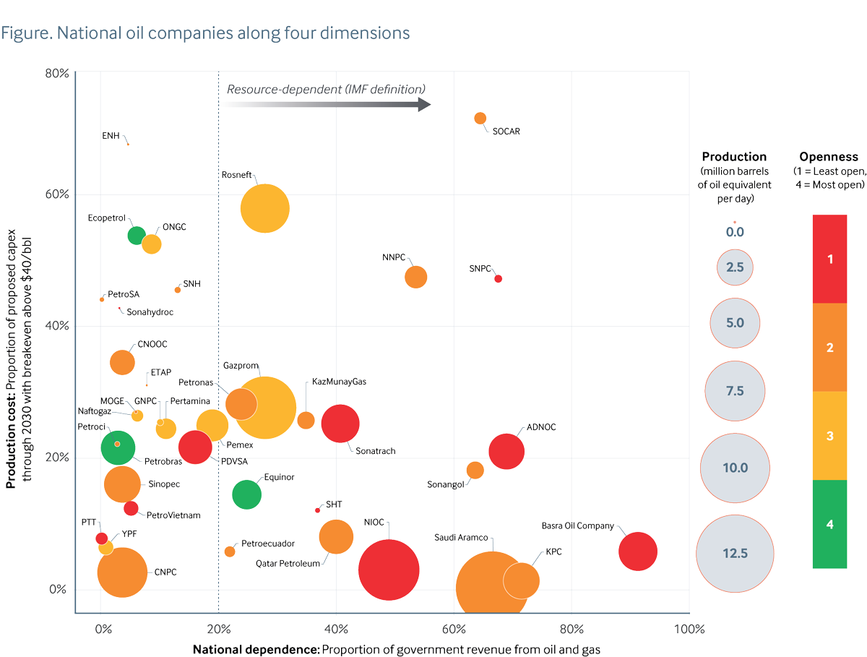
States realized that most of the value in oil comes from owning reserves, not just operating them.
By nationalizing, governments captured:
Resource rents (huge margins when prices rose), tax and royalty flows and control over production pace
NOCs allowed governments to convert oil to a policy tool ( not just a commodity) where, fund welfare states ( Gulf countries), support industrialization or even use it as oil supply in foreign policy
Basically National Oil Companies are not just companies, indeed, they’re extensions of the state.
As a conclusion, in this stage OPEC implements the Official Selling Price (OSP), coordinated production levels among member states, responded strategically to geopolitical events (such as the 1973 oil embargo).
For the first time, pricing power shifted decisively from private corporations to sovereign states.
Stage 2: Stabilization and the Role of Saudi Arabia
Following the turbulence of the 1970s the global oil system entered a new phase during the lates 70´s and especially the 1980s.
There was an attempt to restore stability and predictability.
In this period, the U.S. did not negotiate directly with OPEC as a whole, but instead built a special strategic relationship with Saudi Arabia that influenced global oil markets both
Saudi Arabia by that time assumed the role of “swing producer”, meaning it adjusted its oil output to balance the global market.
Basically, when prices rose too high, Saudi Arabia increased production to cool the market.
When prices fell too low, it cut production to support prices.
However, being the swing producer came at a cost, Saudi Arabia often had to sacrifice market share
Other OPEC members sometimes overproduced, benefiting from higher prices while Saudi Arabia absorbed the adjustment burden.
This tension became especially visible in the mid-1980s, when Saudi Arabia temporarily abandoned this role, contributing to a sharp oil price collapse in 1986.
Managed markets and informal order
During this stage, the oil market functioned as a kind of informal order, on one hand we had OPEC set production targets, but at the same time we had Saudi Arabia enforced discipline indirectly through its output decisions.
At booths cases oil Prices were not fully free-market, but neither were they strictly fixed.
This situation, created a fragile equilibrium where the market was stable enough to avoid extreme volatility, but dependent on cooperation that was often imperfect.
The rapid economic growth of Asia.
We have been talking lately about the supply (export) side, but what about the demand side?
While supply-side stabilization was being attempted, countries like China or India, began accelerating industrialization and urbanization, and as I already explained in other articles about the export increasing and Baltic Dry Index, that lead to:
Surging energy consumption, Increasing dependence on imported oil and Long-term upward pressure on global demand
At first, in the 1980s, this trend was still emerging.
But by the 1990s and especially the 2000s, it became a decisive force reshaping the oil market.
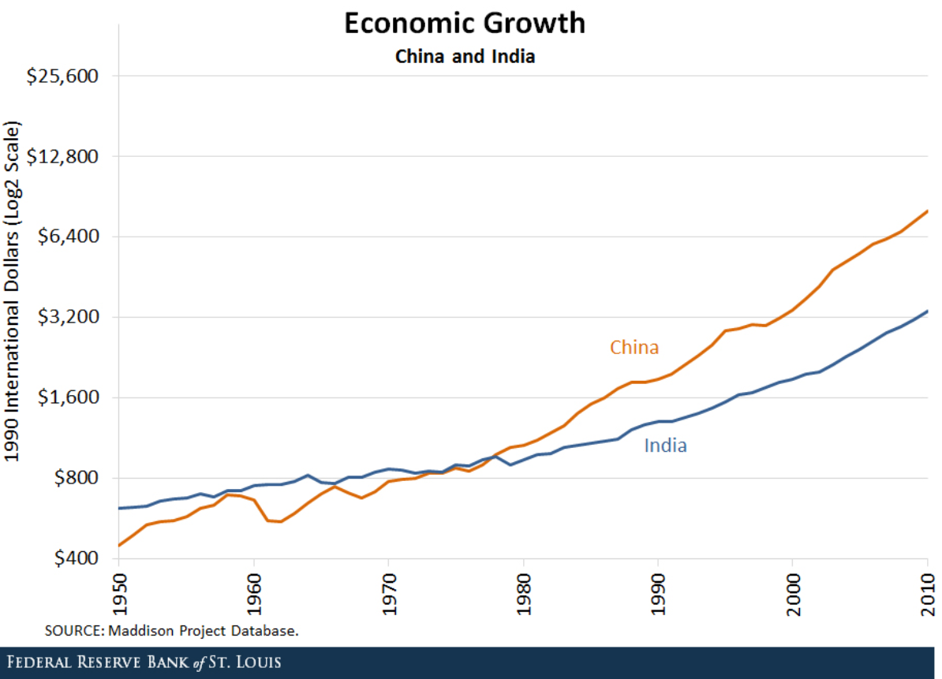
Stage 3: The Strategic Turn of 1998

In this stage, in which Russia gained greater importance after the collapse of the USSR in 1991, the new Russian state shifted from a planned economy typical of communist countries to becoming an exporter and participant in the open market.
Russia saw oil as a source of foreign currency earnings, but during this transition it did not coordinate with OPEC (the Organization of the Petroleum Exporting Countries).
As a result, the organization became destabilized, since other countries began to produce and export more oil. This led to oversupply and, consequently, a decrease in the price per barrel.
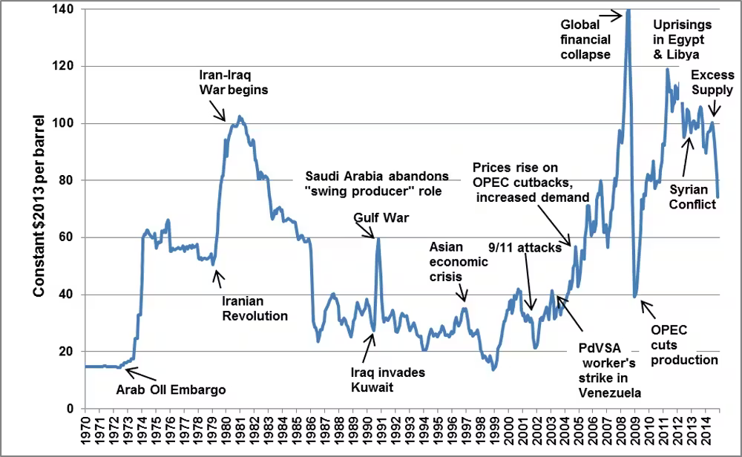
Everything reaches its worst point for oil prices when the Asian Financial Crisis of 1997 occurred. This crisis consisted of a loss of confidence in the economies of Southeast Asia, especially in currencies such as the Thai baht.
At that time, many countries maintained a stable exchange rate with the US dollar. However, after years of strong inflows of foreign capital and increasing debt, a financial bubble developed. When this bubble began to collapse, investors rapidly withdrew their money and sought to exchange local currencies for US dollars.
This led to a sharp devaluation of local currencies and, as a result, debts denominated in dollars became much more expensive to repay. The situation triggered capital flight, bank failures, and a deep economic recession.
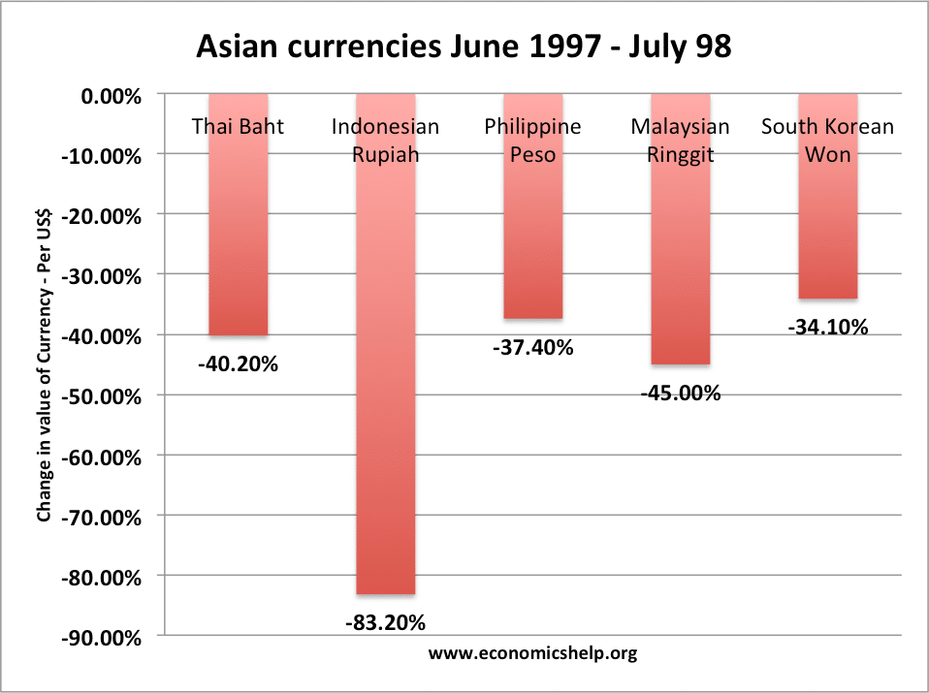
This recession reduced economic activity in the region and, therefore, decreased the demand for oil, contributing to the fall in global crude oil prices.
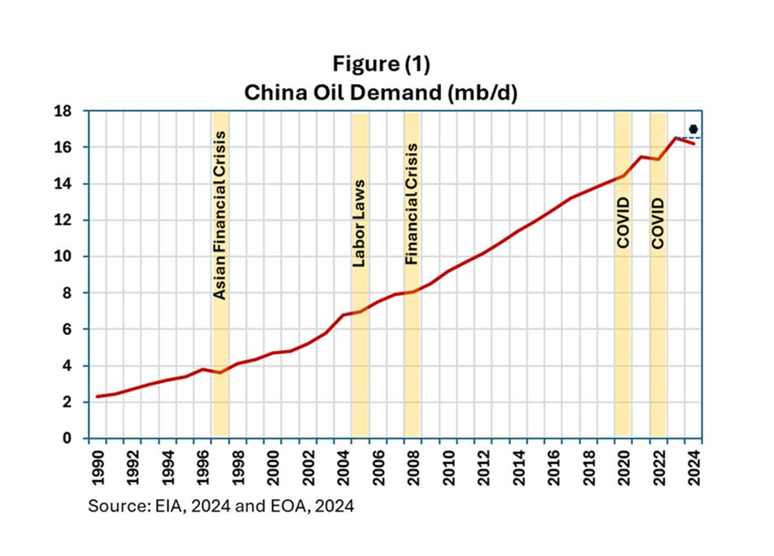
This chain of events caused oil prices to fall to around 10 dollars per barrel. The decline was mainly due to a reduction in global demand following the Asian financial crisis, combined with an excess of supply from major producers.
For oil-exporting countries, such as members of the OPEC or Russia, this represented a severe fiscal shock, as their revenues are highly dependent on oil.
In the case of Russia, the drop in oil prices drastically reduced foreign currency revenues, preventing the state from servicing its external debt and leading to the 1998 default. As a consequence, the ruble was sharply devalued, and the banking system entered a crisis due to loss of confidence and the insolvency of several institutions.
The real change of 1998
The major change was a shift in mindset. The 1970s were characterized by limited supply, where oil prices were mainly driven by supply shocks and armed conflicts.
However, after the Asian crisis, it became clear that if OPEC wanted to survive, it had to learn how to manage risk and oil prices more actively.
From that point on, the financial system and demand from the Asian continent, especially mainland China, increasingly determined the value of “black gold.”
For this reason, between 1998 and the early 2000s, various financial hedging instruments were introduced for oil pricing, marking the entry of crude oil into the futures markets.
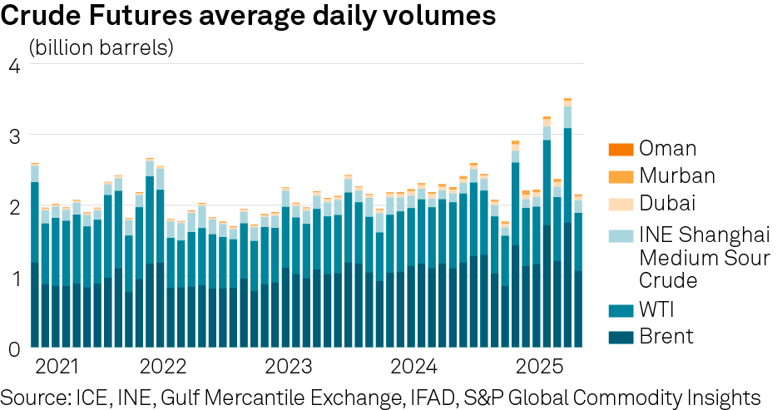
Investment funds, banks, and hedge funds began to operate massively in derivatives such as futures and options on crude oil, which meant that oil stopped being only a physical commodity and also became a global financial asset.
Where oil was once traded mainly for physical use, it now also “prices in” interest rates, inflation, and global risk conditions.
This introduces an additional layer of volatility, as large flows of financial capital can enter or exit the market without any direct connection to the physical consumption of oil.
For oil-exporting countries seeking economic independence, this is negative news. For example, Russian oil (Urals oil) becomes increasingly determined by external dynamics outside the producing country.
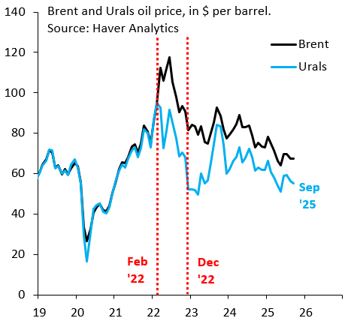
Although Russia remains a key exporter, the price of Urals is no longer primarily set by Russia’s own production and export balance, but by international benchmark prices (such as Brent or WTI), which are themselves influenced by global financial markets.
This means that factors such as central bank decisions, speculative movements, or shifts in global market sentiment can directly affect the value of Russian oil, even if Russia’s production has not changed.
As a result, Russia loses part of its indirect control over the real value of its main export: its economy becomes much more exposed to global financial cycles.
In other words, the price of Urals stops being a “national reflection” of Russian supply and becomes a “globalized price,” determined by foreign markets and international financial actors.
This increases both the volatility of Russian state revenues and its dependence on global market behavior, beyond the real physical fundamentals of oil.

